**ECE 241 Digital Systems**

**Final Project**

**(Brief Overview)**

**Team Members:** Naveed Ashfaq, Stephen Phung

**Description of Project:**

* A board game played on a Monopoly-like board.
* Each player turn-wise moves around the board cyclically collecting points.
* After all players complete all objectives, player with highest points is declared the winner.

**Block Diagram:**

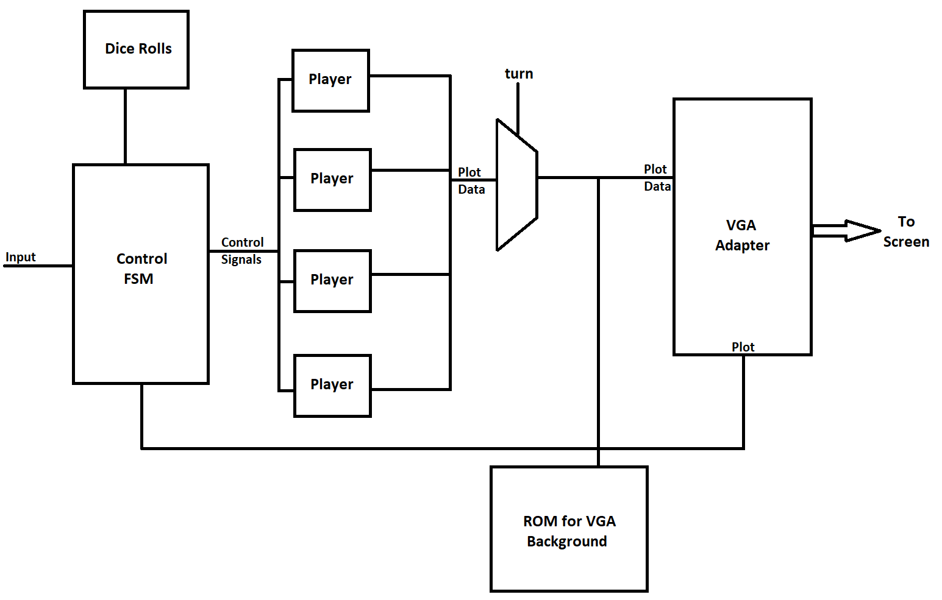

**Milestones:**

* **Week 1:** Implement random dice rolls. Have sprites of the players that move correctly across the screen (mimicking the movement on a monopoly board) and according to player turn.
* **Week 2:** Store, update and display each player’s score as play progresses. Also record each players’ progress to game completion.
* **Week 3:** Replace board key inputs with keyboard controller. Final working version of the game.